INDIAN SPACE RESEARCH ORGANIZATION
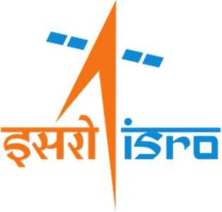
ISRO Telemetry, Tracking and Command Network

( ISTRAC )

Internship Report on

“OPTIMIZATION OF AUTOCORRELATION FOR

GNSS APPLICATION USING AI/ML TECHNIQUES”

Submitted By

Bindushree A

B.E in Computer Science and Engineering
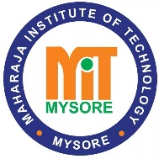
( 28/01/2026 – 29/05/2026 )

Maharaja Institute of Technology Mysore

Under the Guidance of: Submitted to:

Dr. Dileep D Mr. B. Sankar Madaswamy
Section Head, NTRS 1 Division Head, HRLD
ISTRAC/ISRO ISTRAC/ISRO
TABLE OF CONTENTS

SI. No | Contents | Page No.
1 | Introduction | 1–3
2 | NavIC | 4–7
3 | Galois Field | 8–9
4 | Linear Feedback Shift Register (LFSR) | 9–10
5 | Primitive Polynomial | 11–12
6 | Autocorrelation and Cross-Correlation | 13–14
7 | Optimization of Periodic Autocorrelation | 15–17
8 | Learning Outcomes | 18
9 | Conclusion | 19
10 | Appendix | 20–44
11 | References | 45

